**Novel Sharing**

**BE-IT Semester- VII**

Prepared at

ISO 9001:2008

ISO 27001:2013

CMMI LEVEL-5

**Bhaskaracharya Institute for Space Applications & Geo-informatics**

**Science & Technology Department, Govt. of Gujarat.**

**Gandhinagar**

**Prepared By**

**Rabari Ramu Timbal Mayank Jamod Bhavdip**

**ID No. M2-82 ID No. M2-83 ID No. M2-84**

**Guided By: External Guide:**

**Prof. Hiteishi Diwanji Digvijaysingh Chauhan**

Head of Department Project Scientist

Information Technology Dept. BISAG- Gandhinagar

L.D. College of Engineering-Ahmedabad

**SUBMITTED TO**

**Gujarat Technological University**

****

**L.D. College of Engineering-Ahmedabad**

Bhaskaracharya Institute for Space Applications and Geo-informatics

****

ISO 9001:2008

ISO 27001:2013

CMMI LEVEL-5

ISO 27001:2005

Department of Science & Technology

Government of Gujarat

Phone: 079 - 23213081 Fax: 079 - 23213091

E-mail: info@bisag.gujarat.gov.in, website: www.bisag.gujarat.gov.in

**CERTIFICATE**

*This is to certify that the project report compiled by* ***Mr*** *.* ***Rabari Ramu , Mr. Timbal Mayank*** *and*  ***Mr. Jamod Bhavdip*** *students of 7th Semester* ***BE-IT from L.D. College of Engineering, Gujarat Technological University, Ahmedabad*** *have completed their summer internship project satisfactorily. To the best of our knowledge this is an original and bonafide work done by them. They have worked on web-based application* ***“Novel Sharing”*** *starting from June 1st, 2019 to June 30th, 2019.*

*During their tenure at this Institute, they were found to be sincere and meticulous in their work. We appreciate their enthusiasm & dedication towards the work assigned to them.*

*We wish them every success.*

**T. P. Singh**

**Director,**

**BISAG, Gandhinagar**

**Digvijaysingh Chauhan**

**Project Scientist,**

**BISAG, Gandhinagar**

 

**CERTIFICATE**

This is to certify that members of Group ID: **M2** namely **RABARI RAMU(160280116078) , TIMBAL MAYANK(160280116104)** and **JAMOD BHAVDIP(160280116031)** studying in L.D. College of Engineering pursuing BE (Information Technology) has successfully completed Summer Internship Project titled **“Novel Sharing”** under the guidance of **Digvijaysingh Chauhan** at **BISAG Gandhinagar**, for the duration 1st June -30th June, 2019.

Date: 26th June 2019 **Prof. Hiteishi Diwanji**

Head of Department

(Information Technology)

L D College of Engineering

Ahmedabad-1

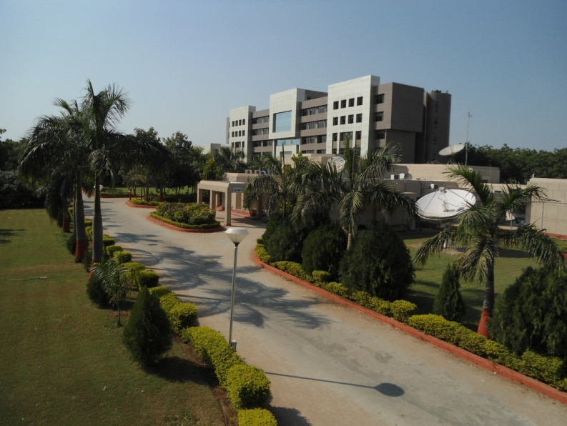About BISAG

ABOUT THE INSTITUTE

Modern day planning for inclusive development and growth calls for transparent, efficient, effective, responsive and low cost decision making systems involving multi-disciplinary information such that it not only encourages people's participation, ensuring equitable development but also takes into account the sustainability of natural resources. The applications of space technology and Geo–informatics have contributed significantly towards the socio-economic development. Taking cognizance of the need of geo-spatial information for developmental planning and management of resources, the department of Science and Technology, Government of Gujarat established "Bhaskaracharya Institute for Space Applications and Geo-informatics" (BISAG). BISAG is an ISO 9001:2008, ISO 27001:2005 and CMMI: 5 certified institute. BISAG which was initially set up to carryout space technology applications, has evolved into a centre of excellence, where research and innovations are combined with the requirements of users and thus acts as a value added service provider, a technology developer and as a facilitator for providing direct benefits of space technologies to the grass root level functions/functionaries.

BISAG's Enduring Growth

Since its foundation, the Institute has experienced extensive growth in the sphere of Space technology and Geo-informatics. The objective with which BISAG was established is manifested in the extent of services it renders to almost all departments of the State. Year after year the institute has been endeavoring to increase its outreach to disseminate the use of geo-informatics up to grassroots level. In this span of nine years, BISAG has assumed multi-dimensional roles and achieved several milestones to become an integral part of the development process of the Gujarat State.

|  |  |  |
| --- | --- | --- |
| BISAG’s Journey | 2003-0403.JPG | Gujarat SATCOM Network |
| 2007-08DSC_2461.JPG | Centre for  Geo-informatics  Applications |
| 2010-11D:\Bharat Work 2011\BISAG-2011\BISAG Broacher 2011\DSC_9696-OK.JPG | Academy of Geo-informatics for Sustainable Development |
| 2012-13 | A full-fledged Campus |

Activities 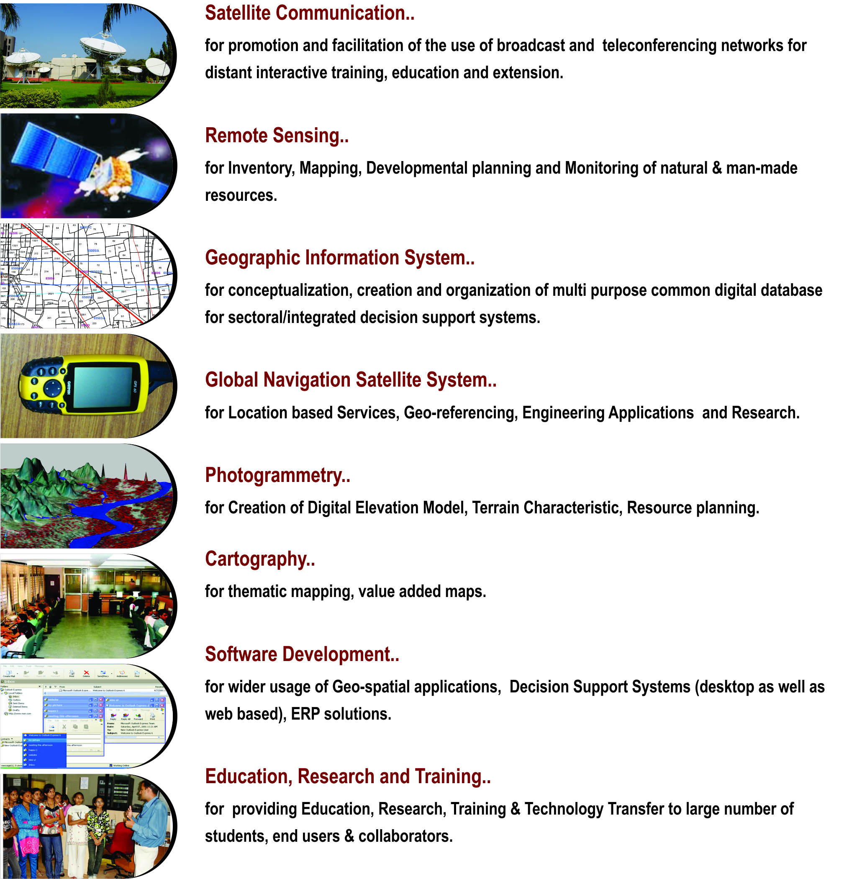

Applications of Geospatial Technology for Good Governance: Institutionalization

Through the geospatial technology, the actual situation on the ground can be accessed. The real life data collected through the technology forms the strong foundation for development of effective social welfare programs benefiting directly the grass root level people. The geospatial data collected by the space borne sensors along with powerful software support through Geographic Information System (GIS), the vital spatio-temporal maps, tables, and various statistics are being generated which feed into Decision Support System (DSS).

A multi-threaded approach is followed in the process of institutionalization of development of such applications. The 5 common threads which run through all the processes are: *Acceptability, Adaptability, Affordability, Availability and Assimilability*.

These are the “Watch Words” which any application developer has to meet. The “acceptability” addresses the issue that the application developed has met the wide acceptability among the users departments and the ultimate end beneficiary by way of providing all necessary data and statistics required. The “affordability” addresses the issue of the application product being cost effective. The “availability” aspect looks into aspect of easily accessible across any platform, anywhere and anytime. The applications should have inbuilt capability of easy adaptability to the changing spatio- and temporal resolutions of data, new aspects of requirements arising from time to time from users. The assimilability aspect ensures that the data from various sources / resolutions and technologies can be seamlessly integrated.

|  |  |
| --- | --- |
| **ACCEPTABILITY** | * + - * Problem definition by users |
|  | * Proof of Concept development without financial liability on users |
|  | * + - * Execution through collaboration under user’s ownership |
| **ADOPTABILITY** | * + - * + Applications as per present systems & database |
|  | * + - * Maximum Automation |
|  | * + - * Minimum capacity building requirement at the user end |
| **AFFORDABILITY :** | * + - * Multipurpose geo-spatial database, common, compatible, standardized (100s of layers) |
|  | * + - * In house developed/open source software |
|  | * + - * Full Utilization of available assets |
| **AVAILABILITY:** | * + - * + Departmental /Integrated DSS |
|  | * + - * + Desired Product delivery anytime, anywhere in the State |

Organizational Setup

The Institute is responsible for providing information and technical support to different Departments and Organizations. The Governing Body and the Empowered Executive Committee govern the functioning of BISAG. The Institute is registered under the Societies Registration Act 1860. Considering the scope and extent of activities of BISAG, its organizational structure has been charted out with defined functions.

Organizational Setup of BISAG

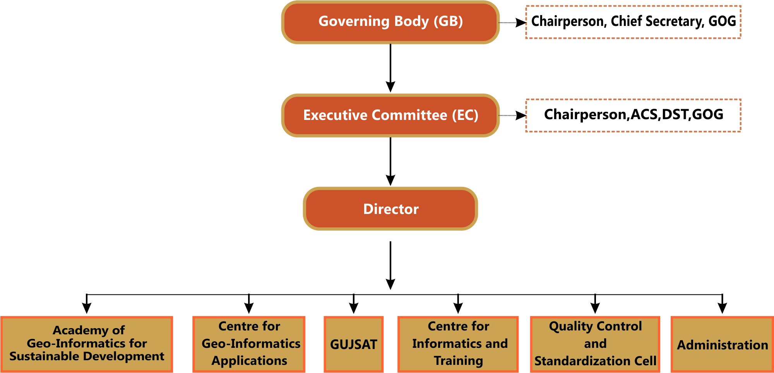

Governing Body

For smoother, easier and faster institutionalization of Remote Sensing and GIS technology, decision makers of the state were brought together to form the Governing Body. It is the supreme executive authority of the Institute. The Governing Body comprises of ex-officio members from various Government departments and Institutes.

* Chief Secretary, Government of Gujarat Chairperson
* Secretary, Science and Technology Member
* Secretary, Finance Department Member
* Secretary, Education Department Member
* Secretary, Revenue Department Member
* Secretary, Panchayats, Rural Housing and Rural Development Department Member
* Director, Space Applications Center, ISRO, Ahmedabad Member
* Dr. George Joseph, Former Director, SAC, ISRO, Ahmedabad Member
* Vice Chancellor, Gujarat University, Ahmedabad Member
* Chief Executive Officer, Gujarat Infrastructure Development Board Member
* Jt. Secretary Invitee
* Director, BISAG Member Secretary

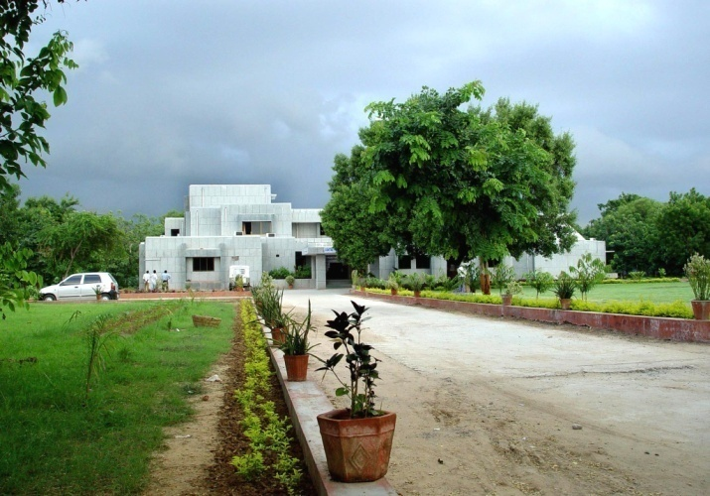Centre  
for  
Geo-informatics Applications

Introduction

The objective of this technology group is to provide decision support to the sectoral stake holders through scientifically organized, comprehensive, multi-purpose, compatible and large scale (village level) geo-spatial databases and supporting analytical tools. These activities of this unit are executed by a well-trained team of multi-disciplinary scientists. The government has provided a modern infrastructure along with the state-of-the-art hardware and software. To study the land transformation and development over the years, a satellite digital data library of multiple sensors of last twenty years has been established and conventional data sets of departments have been co-registered with satellite data. The geo-spatial databases have been created using conventional maps, high resolution satellite 2D and 3D imagery and official datasets (attributes).The geo-spatial databases include terrain characteristics, natural and administrative systems, agriculture, water resources, city survey maps, village maps with survey numbers, water harvesting structures, water supply, irrigation, power, communications, ports, land utilization pattern, infrastructure, urbanization, environment data, forests, sanctuaries, mining areas, industries. They also include social infrastructure like the locations of schools, health centers, institutions, aganwadies, local government infrastructure etc. The geospatial database of nagar-palikas includes properties and amenities captured on city and town planning maps with 1000 GIS layers. Similar work for villages has been initiated as a pilot project.

The applications of space technology and geo-informatics have been operational in almost all the development sectors of the state. Remote sensing and GIS applications have provided impetus to planning and developmental activities at grass root level as well as monitoring and management in various disciplines.

The GIS based Applications Development

The GIS software is a powerful tool to handle, manipulate and integrate both the spatial and non-spatial data. The GIS system operates on the powerful backend data base and Sequential Query Language (SQL) to inquiry the data bases. It has the capability to handle large volume of data and process to yield values of parameters which can be input to very important government activity as Decision Support System (DSS). Its mapping capabilities help the users and specialists in generating single and multi-theme wise maps.

The GIS based applications development has been institutionalized in BISAG. This process can be listed as (Refer Figure for Details)

* Making the users aware of the GIS capabilities through introductory training programme and by exposing to already developed projects as success stories.
* Helping the users in defining the GIS based projects.
* Digitizing the data available with the users and encouraging them to collect any additional data as may be required.
* Generating the appropriate data bases with the full involvement of the users following the data bases standards

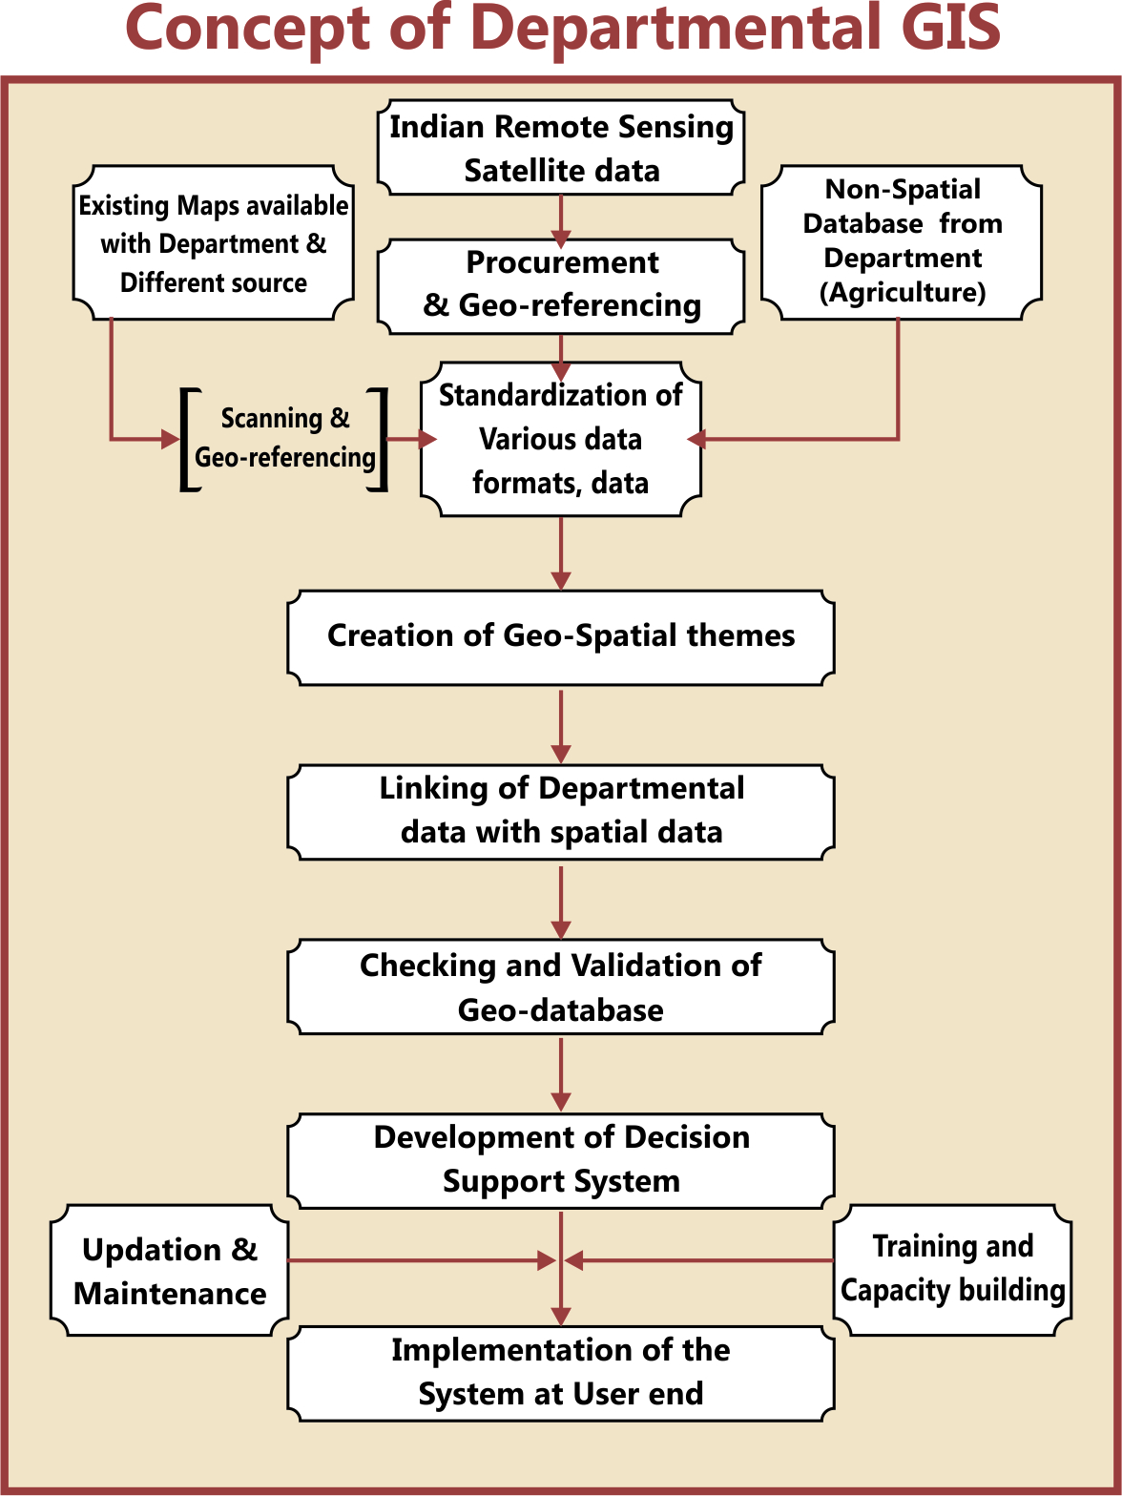

Remote Sensing and GIS Sectoral Applications:

Geo-informatics based Irrigation Management and Monitoring System

* The Geo-spatial information system for Irrigation water Management and Monitoring system for command areas in Sardar Sarovar Narmada Nigam Limited (SSNL) has been developed. Satellite image-based Irrigation monitoring system has been developed in GIS. From the multi-spectral Satellite images of every month, the irrigated areas were extracted.
* The irrigated area were overlaid on the geo-referenced cadastral maps and the statistics of area irrigated has been estimated.
* The user friendly Customized Decision Support System (DSS) has been developed.

**Preparation of DPR of Par–Tapi-Narmada Link using Geo-informatics for National Water development Agency (NWDA)**

* The main objective of Par–Tapi-Narmada Link project is to divert surplus water available in west flowing rivers of south Gujarat and Maharashtra for utilization in the drought prone Saurashtra and Kachcha. On the request from NDWA, preparation of various maps for proposed DPR work was undertaken by the BISAG. Land use and submergence maps of proposed dams along with its statistics have been prepared by the BISAG. The detailed work consisted of generation of Digital Elevation Model (DEM), contour generation, Land use mapping, forest area generation of submergence extent at different levels etc.

**Agriculture**

**District and Village-level Crop Inventory**

* Remote Sensing (RS) based Village-level Crop Acreage Estimation at was taken up in two villages of Anand and Mehsana districts of Gujarat state. The major objective of this study was to attempt village-level crop inventory during two crop seasons of Kharif (monsoon season) and Rabi (winter season) using single-date Indian Remote Sensing (IRS) LISS-III and LISS-IV digital data of maximum vegetative growth stage of major crops during each season.
* District-level crop acreage estimation during three cropping seasons namely Kharif, Rabi and Zaid (summer) seasons was also carried out in all the 26-districts of Gujarat State. Summer crop acreage estimation Gujarat State was carried out during 2012.

**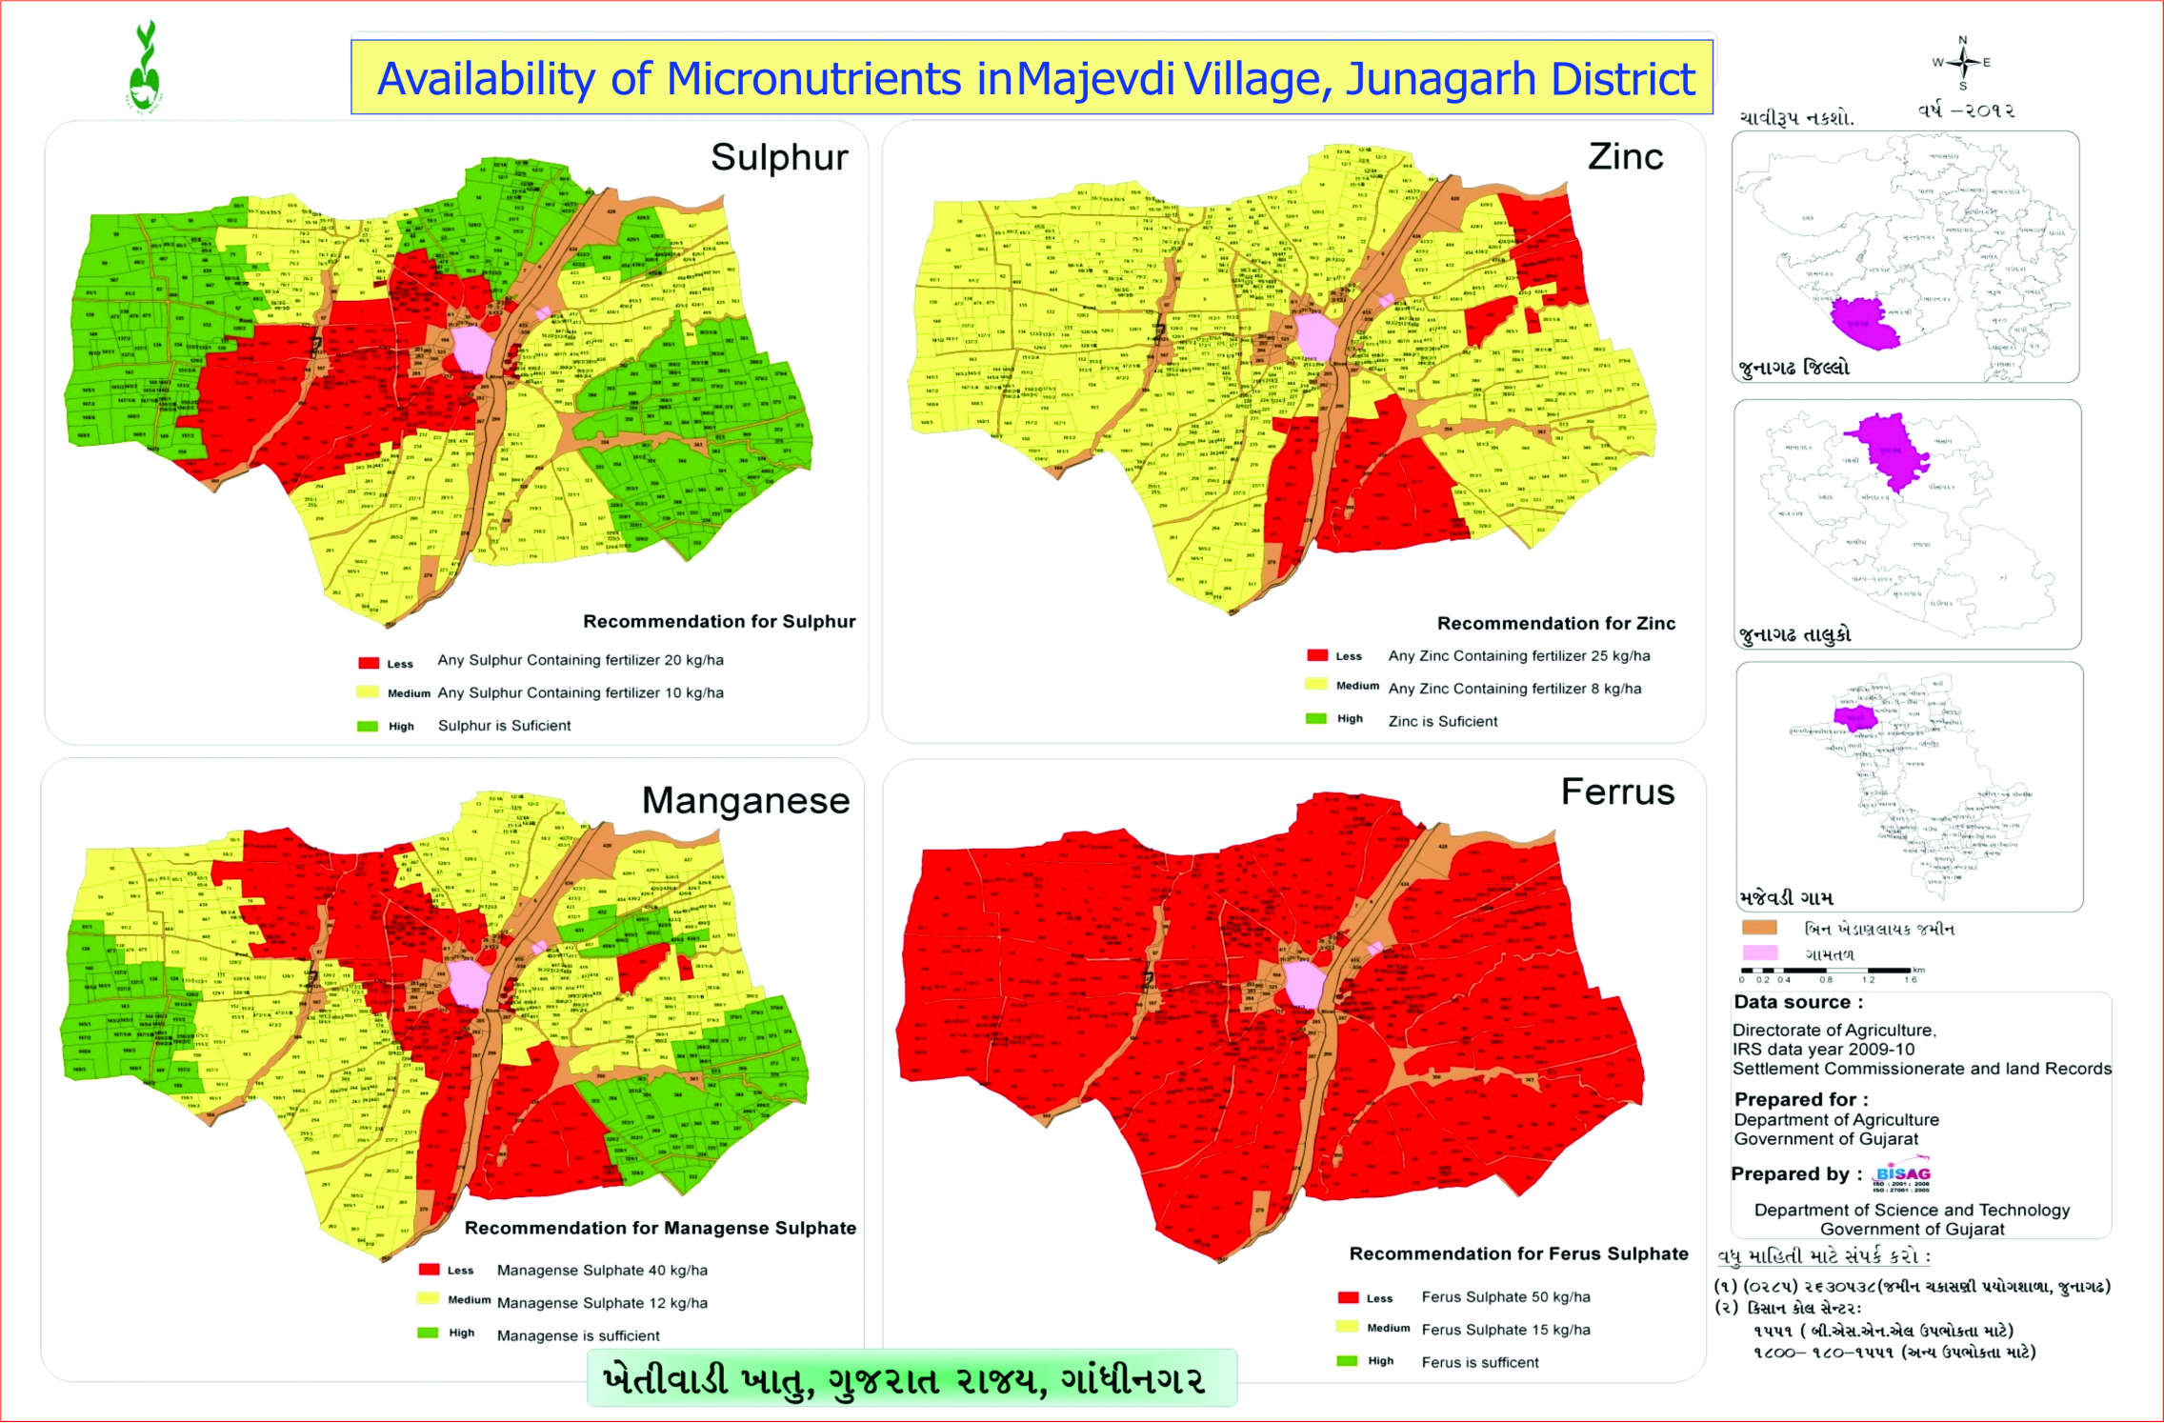Spatial Variability Mapping of Soil Micro-Nutrients**

* The spatial variability of soil micro-nutrients like Fe, Mn, Zn and Cu in various villages of different districts, Gujarat state was mapped using geo-informatics technology. The major objectives of this study were i) to quantify the variability of Mn, Fe, Cu and Zn concentration in soil; ii) to map the pattern of micro-nutrient variability in cadastral maps, iii) suggest proper application of micro-nutrients based on status of deficiency for proper crop management and iv) preparation of village-level atlases showing spatial variability of micro-nutrients.

Geo-spatial Information System for Coastal Districts of Gujarat

* The project on development of Village-level Geo-spatial Information System for Shrimp Farms in Coastal Districts of Gujarat, was taken with major objective of development of Village-level Geo-spatial Information System for Shrimp/Scampi areas using Remote Sensing (RS) and GIS. This project was sponsored by the Marine Products Export Development Authority (MPEDA), Ministry of Commerce & Industry, Government of India for scientific management of Scampi farms in the coastal  districts which can help fishermen to better their livelihood and increase the economic condition on sustainable basis. The customized query shell was developed using the open source software for sharing the information amongst the officers from MPEDA and potential users. This has helped the farmers to plan their processing and marketing operations so as to achieve better remunerations.

Environment and Forest

****

**Mapping and Monitoring of Mangroves in the Coastal Districts of Gujarat State**

* Gujarat Ecology Commission, with technical inputs from the Bhaskaracharya Institute for Space Applications and Geo-Informatics (BISAG) made an attempt to publish Mangrove Atlas of the Gujarat state. Mangrove atlas for 13-coastal districts with 35-coastal talukas in Gujarat, have been prepared using Indian Remote sensing satellite images. The comparison of mangrove area estimates carried out by BISAG and Forest Survey of India (FSI) indicates a net increase in the area under mangrove cover. The present assessment by BISAG, has recorded 996.3 sq. km under mangrove cover, showing a steep rise to the tune of 88.03 sq. km. In addition to the existing Mangrove cover, the present assessment also gives the availability of potential area of 1153 sq. km, where mangrove regeneration program can be taken up.

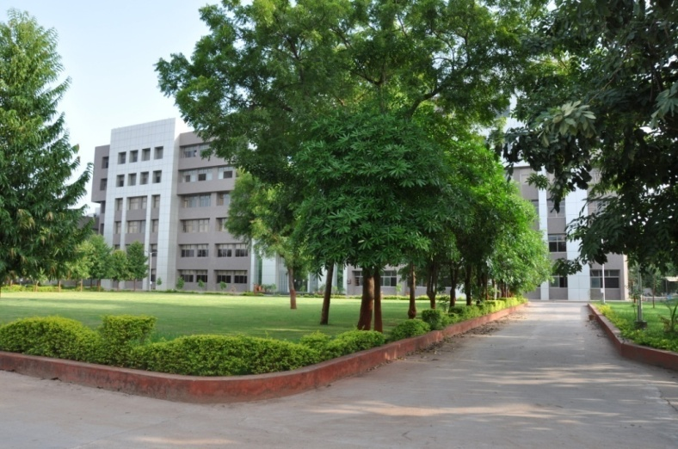Academy   
of  
Geo-informatics

for  
Sustainable

Development

Introduction

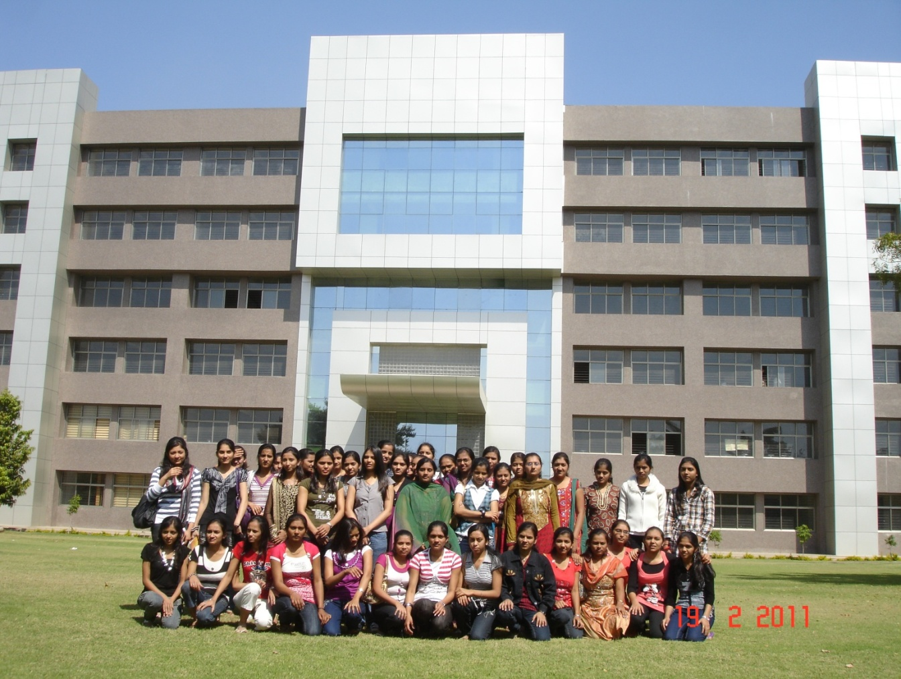

* Considering the requirement of high end research and development in the areas having relevance of geo-informatics technology for sustainable development, a separate infrastructure has been established. In collaboration with different institutes in the state as well as in the country, R&D activities are being carried out in the areas of climate change, environment, disaster management, natural resources management, infrastructure development, resources planning, coastal hazard and coastal zone management studies, etc. under the guidance of eminent scientists.
* Various innovative methodologies/models developed in this academy through the research process have helped in development of various applications. There are plans to enhance R&D activities manifold during coming years.
* This unit also provides training to more than 600 students every year in the field of Geo-informatics to the students from various backgrounds like water resources, urban planning, computer Engineering, IT, Agriculture in the areas of Remote sensing, GIS and their applications.
* This Academy has been established as a separate infrastructure for advanced research and development through following schools:
* School of Geo-informatics
* School of Climate & Environment
* School of Integrated Coastal Zone Management
* School of Sustainable Development Studies
* School of Natural Resources and Bio-diversity
* School of Information Management of Disasters
* School of Communication and Society

During XIIth Five year Plan advance applied research through above schools shall be the main thrust area. Already M. Tech and Ph.D. students of other Universities/ Institutes are doing research in this academy in applied sciences under various collaborative programmes.

M. Tech. Students' Research Programme

The academy started M. Tech. students' research programme in a systematic way. It admitted 11 students from various colleges and universities in Gujarat, Rajasthan and Madhya Pradesh for period of 10 months from August 2011 to May 2012. All the students were paid stipend of Rs. 6000 per month during the tenure. The research covered the following areas:

* Cloud computing techniques
* Mobile communication
* Design of embedded systems
* Aquifer modeling
* Agricultural and Soils Remote Sensing
* Digital Image processing Techniques (Data Fusion and Image Classification).

The research resulted in various dissertations and publications in national and international journals.

* Now nine students, one from IIT, Kharagpur, three from GTU, one from M. S University, Vadodara and four from GU, are undergoing their Ph. D programme. Out of nine, two thesis have been submitted. Two students are from abroad. One each from Vietnam and Yemen. Since then (after approval of research programme from the Governing Body), 200+ papers have been published by the Academy

**CANDIDATE’S DECLARATION**

We declare that summer internship project report entitled “**Novel Sharing**” is our own work conducted under the supervision of the external guide **Digvijaysingh Chauhan** from BISAG (Bhaskaracharya Institute for Space Applications & Geo-informatics).We further declare that to the best of my knowledge the report for project does not contain part of the work which has been submitted for the award of Bachelor Degree either in this or any other university without proper citation.

Rabari Ramu

Student ID: M2-82

Timbal Mayank

Student ID: M2-83

Jamod Bhavdip

Student ID: M2-84

**Submitted To:**

L.D. College of Engineering

Gujarat Technological University,

Ahmedabad.

**ACKNOWLEDGMENT**

We are grateful to **T.P.Singh**, **Director (BISAG)** for giving us this opportunity to work the guidance of renowned people of the field of MIS Based Portal also providing us with the required resources in the company.

We would like to express our endless thanks to our project guide **Digvijaysingh Chauhan**, And Admin Staff **Mr.Saurabh Bhabhor** and **Mr.Sidhdharth Patel** at Bhaskaracharya Institute of Space Application and Geo-informatics for their sincere and dedicated guidance throughout the project development.

Also our hearty gratitude to our Head of Department, **Mrs. Hiteishi Diwanji** for giving us encouragement and technical support on the project.

**Rabari Ramu**

Student ID: M2-82

**Timbal Mayank**

Student ID: M2-83

**Jamod Bhavdip**

Student ID: M2-84

|  |  |  |
| --- | --- | --- |
| **CONTENTS** | | |
| **Chapter No.** | **Description** | **Page No.** |
| **1** | **Introduction** | **19** |
|  | 1. Project Details   1.2 Purpose  1.3 Scope  1.4 Objective  1.5 Technology |  |
| **2** | **Project Management** | **20-22** |
|  | * 1. Feasibility Study   2.1.1 Technical Feasibility  2.1.2 Time Schedule Feasibility  2.1.3 Implementation Feasibility  2.2 Project Planning  2.2.1 Project Development Approach and Justification  2.2.2 Milestone & Deliverables  2.2.3 Roles & Responsibilities  2.2.4 Group Dependencies  2.3 Project Scheduling |  |
| **3** | **System Requirement Study** | **23-24** |
|  | 3.1 Study of Current System  3.2 Problems and weakness of current system  3.3 User characteristics  3.4 Hardware and Software Requirements  3.5 Constraints  3.5.1 User Interface  3.5.2 Communications Interface  3.5.3 Hardware Interface  3.5.4 Safety and security consideration  3.6 Assumption and dependencies  3.6.1 Assumptions  3.6.2 Dependencies |  |
| **4** | **Requirement of Proposed System** | **25-26** |
|  | 4.1 Main Module of the System  4.2 Module Descriptions  4.3 Features of New System |  |
| **5** | **System Design** | **27-35** |
|  | 5.1 System Architecture Design  5.1.1 E-R Diagram  5.1.2 Use case Diagram  5.1.3 Class Diagram  5.1.4 Deployment Diagram  5.2 Database Design  5.2.1 Table and Relationship  5.2.2 Logical Description of Data  5.3 Snapshots |  |
| **6** | **Implementation Planning** | **36-40** |
|  | 6.1Implementation Environment  6.2Coding Standard |  |
| **7** | **Testing** | **41-42** |
|  | 7.1 Testing Plan  7.2 Testing strategy |  |
| **8** | **Limitations and Future Extensions** | **43** |
| **9** | **Conclusions and Reference** | **44** |
|  | 9.1 Conclusion  9.2 Reference |  |
| **10** | **Report Verification Procedure** | **45** |

CHAPTER: 1 Introduction

# Project details

Sharing books is the most basic form of sharing knowledge. But, sharing Novel manually may be tedious and not always convenient. The project aims at providing an Internet medium to share books and provide readers with a platform. The system provides a platform for any user, who has a book that is already read by user and want to use other books in exchanging with current book and would like to share it with another user that may have the need for it. This shall be accomplished by developing a cross platform that incorporates the leading web technologies of today.

# Purpose

The main purpose of developing this system is to provide online book exchange system with web application. One does not need to pay money each and every time while exchanging book.

# Scope

This system can be used by students, book lovers etc.

# Objective

As this system deals with Exchange and use main objective is to help connect book owners who are interested in sharing their used books with other book owners' used books. It's a win-win because everyone gets to enjoy a new book to read without needing to spend the extra cash making more space at home to store old books. So with this system end users can easily got new books and no need to buy books which are available on system.

# Technology and Literature Review

**Technology:**

The technology which is used in developing this system is as listed below:

* Servlet
* JSP
* CSS
* JavaScript
* MYSQL Database
* Glassfish Server

CHAPTER: 2 Project Management

# Feasibility study

* + 1. **Technical feasibility**
* Each servlet class is independently developed and so if multiple users send request by uploading images of books than they will be handled which reduces server load and execution time of the system
* The information from the user is stored in database directly and so only database is supposed to be stored at server side and hence the data is stored securely and is authenticated.
* User can contact to sharer on WhatsApp through WhatsApp API.

* + 1. **Time Schedule feasibility**
* The project was developed using standard iterative model. Different modules such as planning, communication, designing, development and deployment were scheduled and worked upon to achieve the project goals.
* Communication and planning took around 2 days after successfully research on the project title and resources were gathered accordingly such that optimal use was formulated.
* After that SRS was developed for the proposed system and finally the designing and development took place. About 20 days were utilized to achieve this and then the system was tested each and every time the module was developed.
* Testing and maintenance strategies were developed and worked upon in the remaining days and the system was analyzed on the basis of validation, authentication, performance and scalability to ensure quality of services.

* + 1. **Implementation feasibility**
* This system can be implemented technically, ethically and securely for any business purpose.

# Project Planning

* + 1. **Project development approach and justification**
* This project was developed using Spiral iterative model

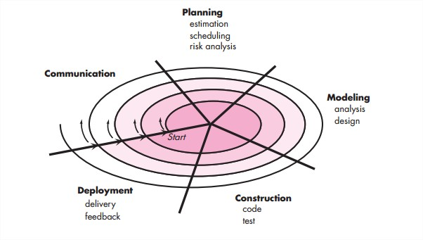

* Reason to use spiral model is there’s a possibility to add some additional functionality at the last stages of software product development. Since risk monitoring and regular expertise are core characteristics of this approach, the overall project becomes more transparent.
* In a week we developer communicate regarding the project updates and the deliverables and features and planning for next iteration
* The advantages of using the spiral model are varied: its design flexibility allows changes to be implemented at several stages of the project; the process of building up large systems in small segments makes it easier to do cost calculations; and the client, who will be involved in the development of each segment, retains control over the direction and implementation of the project. In addition, the client's knowledge of the project grows as the project grows, so that they can interface effectively with management.

**2.2.2 Milestones and deliverables**

* We were able to achieve the soul purpose of developing our system and the overall functionality was successfully achieved before the deadline and was delivered before the promised date.
* The system was deployed as a software in CD .
  + 1. **Roles and responsibilities**
* This system can be used by any individual users logging in system
* We developers provide with the responsibility of maintenance and regular updates as post deployment services if they need in case of any faults or technical issue.
  + 1. **Group Dependencies**
* Each uploaded images of book get connected with the unique book id so easily access it.
* Also the database is dependent on servlets and so servlet execution in desired manner is necessary.
* This system is developed using several libraries and so the library in the environment which is supposed to be used must have those libraries for execution of system.
* Above all as this is web application and so it is totally dependent on internet connection.
* Moreover, this system requires updated version of browsers so that user can interpret and use the system accordingly to serve its purpose.

CHAPTER: 3 System Requirement Study

# Study of current system

* Today we are dealing with the manual book sharing but this is somehow new concept of exchanging.
* To overcome such situation we jointly put forward over efforts and developed new online system for exchanging

# Problems and weakness of current system

* There is no such a platform available.
* User is not able to get desired book.

# User Characteristics

* End users: End user will upload their book image and information will be stored in database will be available on website so other user can request.
* Server: The incoming request will be handled by server and also maintain session of user. store data of users and books

# Hardware and Software Requirements

* Hardware requirement

Any mobile or desktop device which have internet connection.

* Software requirement

Updated version of browser on which the system is executing.

Various libraries to implement system and MYSQL database for data storing and management.

# Constraints

* + 1. **User interface**
* Updated versions of browser is must else the interface would not work effectively.
* As this system is web based so interface will work only if there is sufficient internet connectivity.
  + 1. **Communications interface**
* Communication will be done using Apache and so it should be implemented on specific system.
  + 1. **Hardware interface**
* Any hardware with 2 GB RAM can be used to implement this system.
  + 1. **Safety and security consideration**
* This system will be implemented using HTTPS as standard protocol so it’s secure
* Also the database is kept securely and is authenticated which can be used by authorized persons only.

# Assumptions and Dependencies

* + 1. **Assumptions**
* Updated browser
* User have at least one book to share
* Provides correct information
* Uploads valid book images
  + 1. **Dependencies**
* Various libraries are already available before system execution.
* Internet Connectivity

CHAPTER: 4 Requirement of Proposed System

# Main module of the system

The system implements various modules which are listed below :

* **Signup Module**
* **Login Module**
* **Book Uploading and Processing Module**
* **Share and Request Module**
* **User Module**
* **Database Module**

# Module Description

* **Signup Module:** This module is provided as user interface for registration to our system so that they can use our features for their ease and comfort.
* **Login Module:** This module provides user with login details and after cross verification of that details with registration details the user can be logged in and can access the system.
* **Book Uploading and Processing Module:** This module will fetch the book details like book name, author name, description of book, etc. and accordingly process them.
* **Share and Request Module :** In this module user can request to another user for book and according to that another user accepts request than they can share book of each other
* **User Module :** This module keeps log of user
* **Database Module :** It keeps records of registered user and their uploaded book details

# Features of new system

## 4.3.1 Send a request

4.3.1.1 Description

* This feature will allow to send a request of exchange book to book owner to start exchange process.

4.3.1.2 Stimulus/Response Sequences

* Send a request.

4.3.1.3 Functional Requirements

* Good data connectivity to ensure the reliable communication at the time.

## 4.3.2 Uploading book details in form of images and text

4.3.2.1 Description

This feature will allow users to safely upload their book details so that their details can be stored in database and can be shown to all users.

4.3.2.2 Stimulus/Response Sequences

* Uploading image and details
* Displaying the confirmation message
* Allowing users to upload another book

4.3.2.3 Functional Requirements

* Data connectivity
* Images size should be less than 200kb.

## 4.3.3 Generating report for admin

4.3.3.1 Description

This feature will generate the final report of all orders which have been made by users and give all details about orders like who have made a request of sharing, when order is placed, for which book, etc.

4.3.3.2 Stimulus/Response Sequences

* Generate a report from database

4.3.3.3 Functional Requirements

* Data connectivity

## 4.3.4 Accept/Deny a request for exchanging book

4.3.4.1 Description

This feature will allow book owner to accept or deny the request of book exchanging of book requester. By this feature if sharer do not interest in reading requester book he may deny and if any other reason of denial as remark.

4.3.4.2 Stimulus/Response Sequences

* Showing request in shared book
* Showing requester’s books
* If Accept select any book of requester
* If Deny give a reason as remark

4.3.4.3 Functional Requirements

* Data connectivity

CHAPTER: 5 System Design

# System Architecture Design

* + 1. **E-R Diagram**

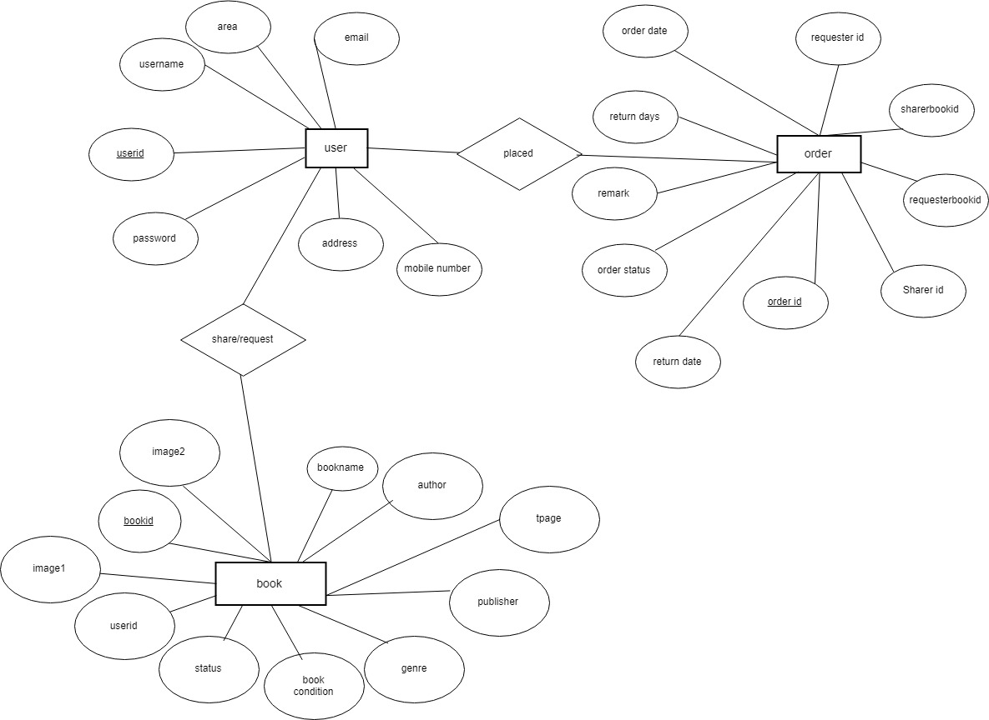

* + 1. **Use Case Diagram**

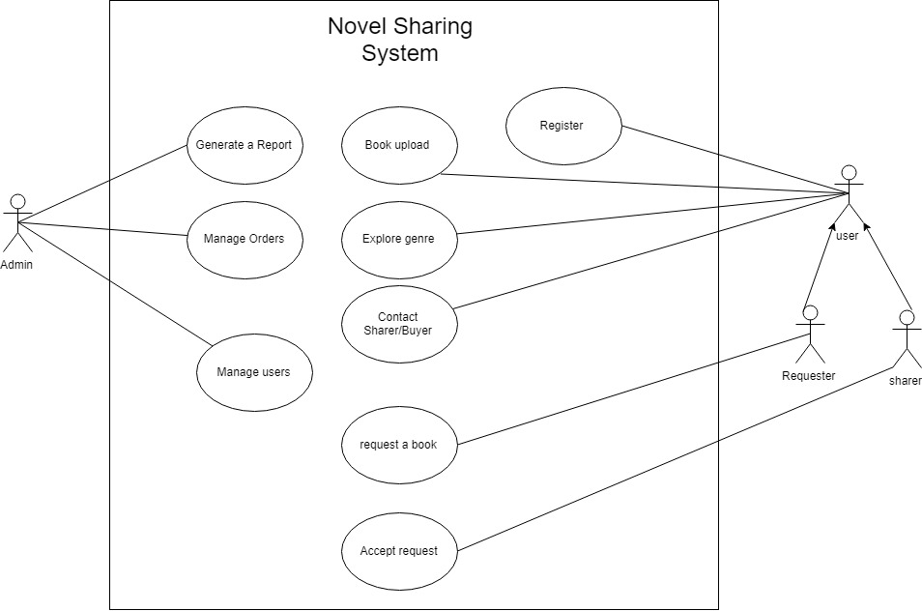

* + 1. **Class Diagram**

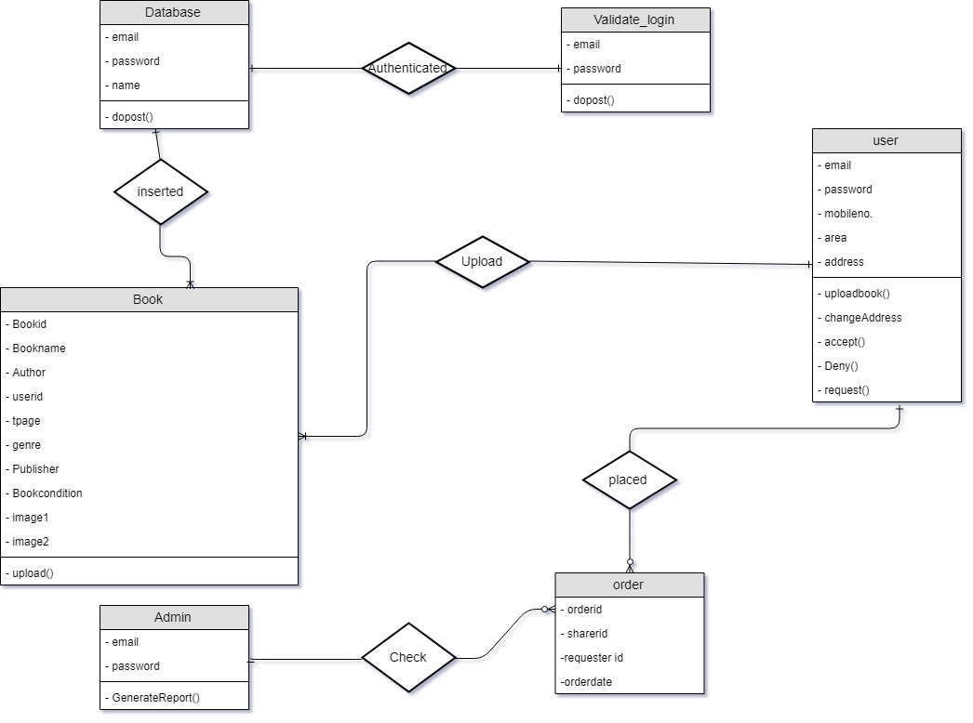

* + 1. **Deployment Diagram**

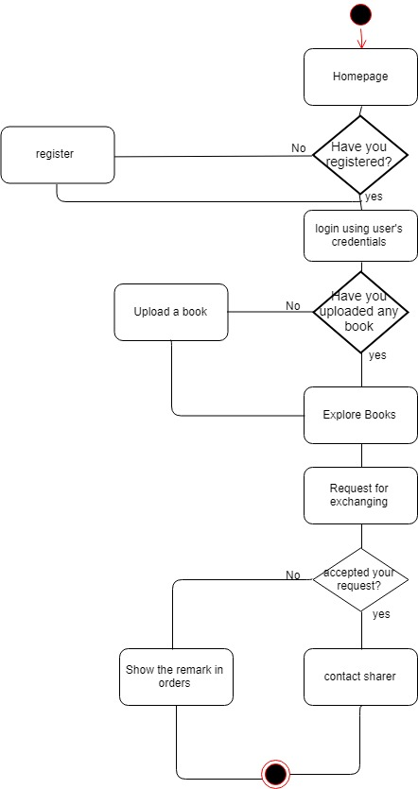

# Database Design

* + 1. **Tables and Relationships**

## area

|  |  |  |  |  |  |  |
| --- | --- | --- | --- | --- | --- | --- |
| **Column** | **Type** | **Null** | **Default** | **Links to** | **Comments** | **MIME** |
| pincode (Primary) | varchar(500) | No |  |  |  |  |
| areaname | varchar(500) | No |  |  |  |  |

### Indexes

| **Keyname** | **Type** | **Unique** | **Packed** | **Column** | **Cardinality** | **Collation** | **Null** | **Comment** |
| --- | --- | --- | --- | --- | --- | --- | --- | --- |
| PRIMARY | BTREE | Yes | No | pincode | 2 | A | No |  |

## book

|  |  |  |  |  |  |  |
| --- | --- | --- | --- | --- | --- | --- |
| **Column** | **Type** | **Null** | **Default** | **Links to** | **Comments** | **MIME** |
| bookid (Primary) | varchar(200) | No |  |  |  |  |
| bookname | varchar(200) | Yes | *NULL* |  |  |  |
| author | varchar(200) | Yes | *NULL* |  |  |  |
| tpage | varchar(200) | Yes | *NULL* |  |  |  |
| genre | varchar(200) | Yes | *NULL* |  |  |  |
| publisher | varchar(200) | Yes | *NULL* |  |  |  |
| bcon | varchar(200) | Yes | *NULL* |  |  |  |
| userid | varchar(200) | No |  |  |  |  |
| username | varchar(200) | No |  |  |  |  |
| eyear | varchar(200) | Yes | *NULL* |  |  |  |
| email | varchar(200) | No |  |  |  |  |
| mobileno | varchar(200) | Yes | *NULL* |  |  |  |
| i1 | blob | No |  |  |  |  |
| i2 | blob | No |  |  |  |  |
| status | varchar(500) | Yes | AVAILABLE |  |  |  |
| bid | varchar(500) | Yes | *NULL* |  |  |  |
| bdesc | varchar(500) | No |  |  |  |  |
| language | varchar(500) | No |  |  |  |  |
| area | varchar(200) | Yes | *NULL* |  |  |  |

### Indexes

| **Keyname** | **Type** | **Unique** | **Packed** | **Column** | **Cardinality** | **Collation** | **Null** | **Comment** |
| --- | --- | --- | --- | --- | --- | --- | --- | --- |
| PRIMARY | BTREE | Yes | No | bookid | 4 | A | No |  |

## ordertable

|  |  |  |  |  |  |  |
| --- | --- | --- | --- | --- | --- | --- |
| **Column** | **Type** | **Null** | **Default** | **Links to** | **Comments** | **MIME** |
| orderid (Primary) | varchar(200) | No |  |  |  |  |
| sid | varchar(200) | Yes | *NULL* |  |  |  |
| reqid | varchar(200) | Yes | *NULL* |  |  |  |
| sbookid | varchar(200) | Yes | *NULL* |  |  |  |
| reqbookid | varchar(200) | Yes | *NULL* |  |  |  |
| odate | timestamp | Yes | *NULL* |  |  |  |
| rdate | timestamp | Yes | *NULL* |  |  |  |
| rdays | varchar(200) | Yes | *NULL* |  |  |  |
| sremark | varchar(6000) | Yes | *NULL* |  |  |  |
| orderstatus | varchar(200) | No | REQUESTED |  |  |  |

### Indexes

| **Keyname** | **Type** | **Unique** | **Packed** | **Column** | **Cardinality** | **Collation** | **Null** | **Comment** |
| --- | --- | --- | --- | --- | --- | --- | --- | --- |
| PRIMARY | BTREE | Yes | No | orderid | 2 | A | No |  |

## user

|  |  |  |  |  |  |  |
| --- | --- | --- | --- | --- | --- | --- |
| **Column** | **Type** | **Null** | **Default** | **Links to** | **Comments** | **MIME** |
| username | varchar(100) | No |  |  |  |  |
| email | varchar(500) | No |  |  |  |  |
| password | varchar(200) | No |  |  |  |  |
| userid (Primary) | varchar(500) | No |  |  |  |  |
| mobile | varchar(200) | No |  |  |  |  |
| area | varchar(200) | No |  |  |  |  |
| address | varchar(500) | No |  |  |  |  |

### Indexes

| **Keyname** | **Type** | **Unique** | **Packed** | **Column** | **Cardinality** | **Collation** | **Null** | **Comment** |
| --- | --- | --- | --- | --- | --- | --- | --- | --- |
| PRIMARY | BTREE | Yes | No | userid | 2 | A | No |  |
| email | BTREE | Yes | No | email | 2 | A | No |  |

[](http://localhost/phpmyadmin/db_datadict.php?db=nosh&table=user&server=1&target=)

* + 1. **Logical description of data**

In above area data table for storing area details and it is retrieved when it is needed. User data table for storing user details like username, password, email etc. Book table for storing book details

# Snapshots

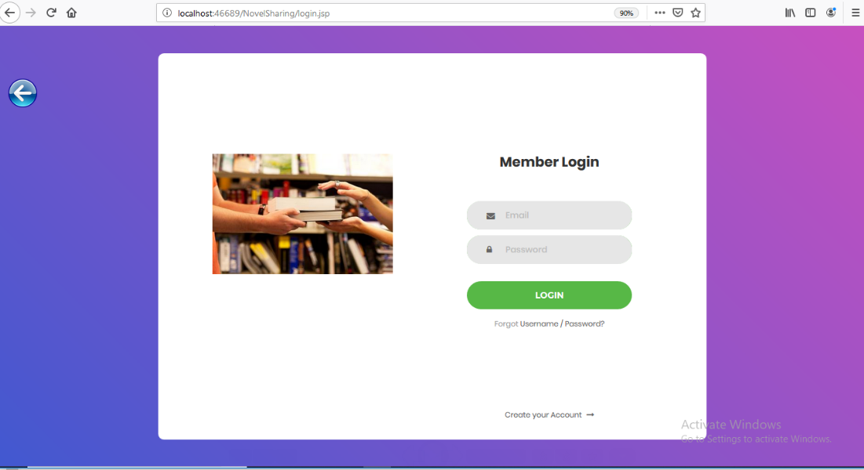

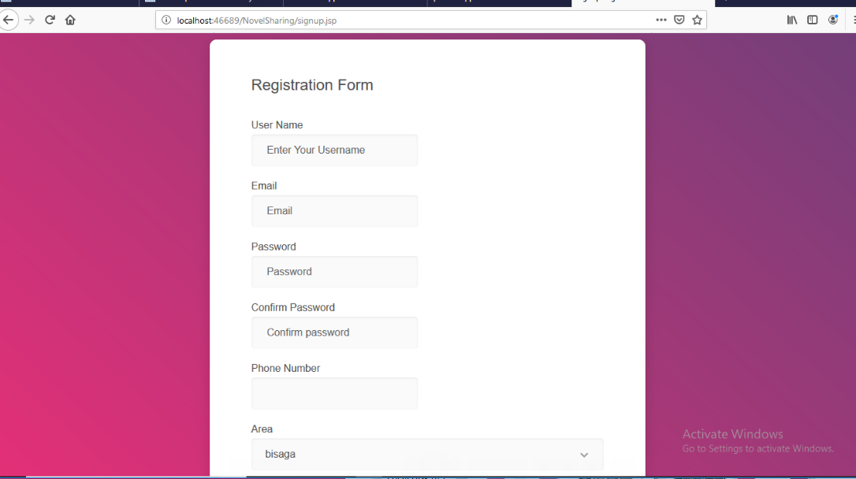

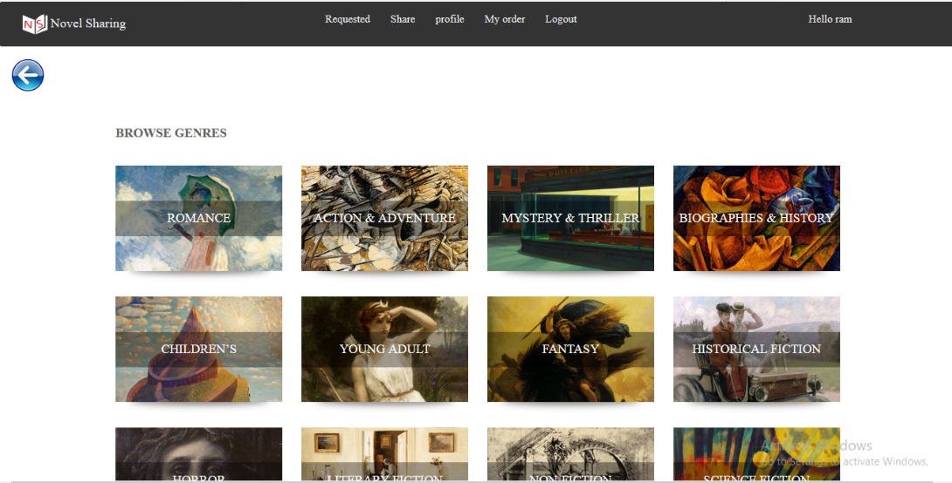

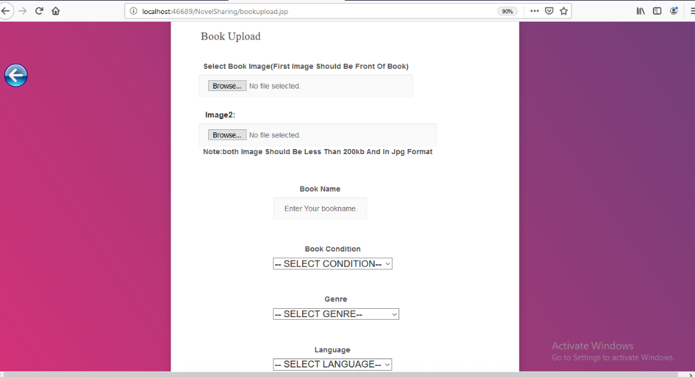

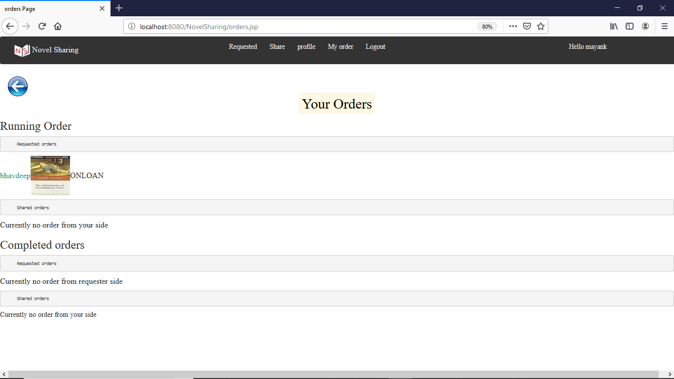

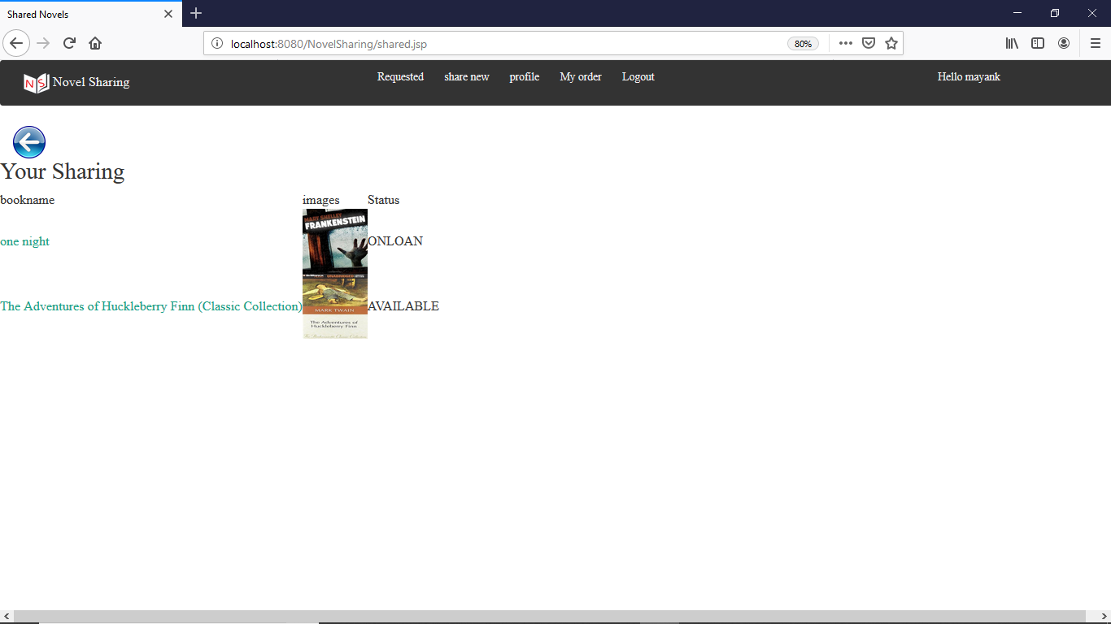

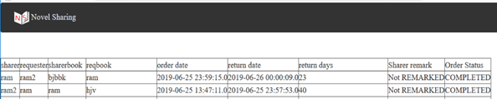

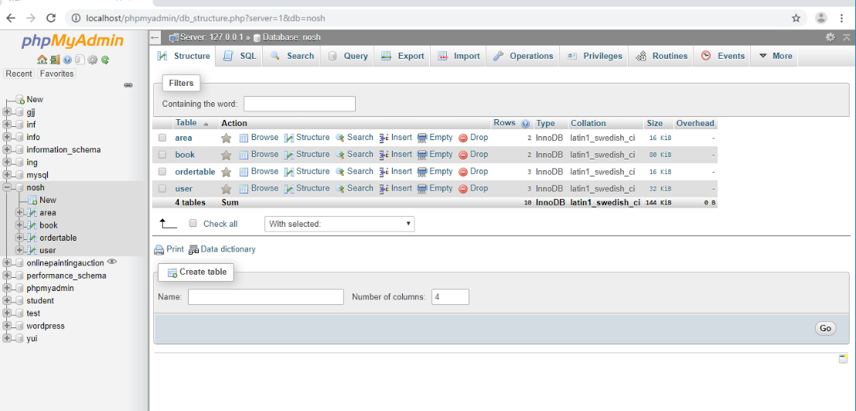

CHAPTER: 6 Implementation Planning

# Implementation Environment

This system can be effectively and efficiently run on hardware with 2GB RAM, updated versions of browser such as Firefox, chrome, IE etc. And on any Operating System as it is developed using JAVA.

# Coding Standard

The term coding standard refers to a set of rules related to writing code that have been standardized in some context, but are not enforced by interpreters or compilers. A coding standard defines and seeks to enforce conventions such as programming language subsets, naming conventions, and coding style for the purpose of improving code quality, which according to Paul Burden consists of the following:

* safety
* security
* maintainability
* portability
* testability.

As compilers are only required to monitor the code for syntax and constraint errors, the purpose of a coding standard is to prevent errors and unwanted behaviour in the code caused by the programmer writing it.

Coding standard conventions

* Structural formatting

Structural formatting of a code document refers to formatting the code structure in a meaningful way, encompassing subjects such as indentation of block statements, syntactically insignificant whitespace, and brace placement. Code formatting generally holds no meaning to code interpreters – the functions in listing 1 perform identically, but the omission of structural formatting renders the function virtually illegible.function get\_string\_file\_size($string, $encoding) { $byte\_count = mb\_strlen($string, $encoding);

if($byte\_count >= 1024) { $file\_size = round($byte\_count / 1024, 2).' KB'; } else { $file\_size = $byte\_count.' bytes'; }

return $file\_size; }

// No structural formatting function get\_string\_file\_size($string,$encoding){$byte\_count=mb\_strlen($string,$encoding);if($byte\_count>=1024){$file\_size=round($byte\_count/1024,2).' KB';}else{$file\_size=$byte\_count.' bytes';}return$file\_size;}

Structural formatting is essentially a matter of programmer preference, considering that it has no direct parallel in natural written language and code interpreters are in different to syntactically insignificant formatting. Structural formatting is however, an integral factor in code comprehension, as it provides visual cues for recognizing program components and their internal logic. Programming is based on the learning and application of models, which in combination with the necessity of structural formatting implies that while there is no right or wrong formatting style, a formatting style should be defined and used consistently.

* Braces

The use and positioning of braces in function declarations and control flow statements has been a topic of debate since they were introduced in programming languages. The debate consists of two points: whether optional braces can be omitted and whether an opening brace should be left or right, as demonstrated // Opening brace to the right function foo() { return { bar: true }; }

// Opening brace to the left function foo() { return { bar: true }; }

Both conventions of opening brace position are used in all web development languages and as interpreters are not affected by this decision, it is a question of preference. JavaScript however, provides an exception due to an oversight in language design – JavaScript implements a feature called ASI (Automatic Semi-colon Insertion). ASI adds a semi-colon to end a statement when it encounters an unallowed token after said statement. The first function in listing 2 returns an object literal where bar equals true, as expected. In the second function ASI inserts a semicolon after the return statement, and the function silently fails, returning undefined. As it fails without producing an error, debugging it is challenging and possibly very time consuming. As the brace convention should be consistent throughout the code, this JavaScript error is the single reason why it is advisable to use the right side brace convention

if($foo == $bar){ echo $first; }

if($foo == $bar) echo $first;

// The second statement echo $second;

Optional braces refer to single-statement control structures, where braces are not required by the interpreter, illustrated in listing 3. Both if-blocks work the same, but if a second statement is added after the first echo-statement, it will only be executed conditionally by the first block. The second if-block will execute the added second statement regardless of whether the condition in the if-statement is met, thus breaking the control flow logic. Avoiding omitting braces is generally met with some resistance, but program logic requires precision and the human brain is not infallible, which is why it is considered good practice to always include braces in control structures to reduce obscurity.

* Whitespace

Whitespace in programming refers to syntactically insignificant blank characters in code, such as the space, tab, and line break characters, making whitespace the cornerstone of structural formatting. Whitespace can be used to format code for readability with conventions such as adding spaces to comma separated lists, adding line breaks between semantically separate code blocks, and adding spaces between tokens in a list of conditions or an operation statement. Established coding standards differ in whitespace rules – for example Drupal coding standards allow no space between control structure parenthesis and their inner statements, while WordPress coding standards require a space before and after each parenthesis. Even though there are no clear winners among whitespace conventions, it is considered good practice to adhere to the whitespace conventions already utilized in the code when extending existing code or adding to a codebase.

While other whitespace conventions are largely matters of preference, indentation of code is considered a de facto standard in structural formatting among programming languages that support it. Indentation emphasizes the logical structure of the code and is seen as an integral part of code readability. The prevalent question within indentation is whether to use tabs or spaces. The WordPress coding standard states that tabs should always be used for indentation, while the Drupal coding standard calls for two space indentation and no tabs. The global programmer community is equally in disagreement on the matter, but there are no unrefuted arguments for either convention, so it is a matter of preference. The conventions should however, not be mixed within a single code document, since tab-stops are not standardized. This means that if the code is written on an editor where tabs are four spaces wide and then viewed on an editor where tabs are eight spaces wide, it can obfuscate the logic structure and reduce readability.

* Naming conventions

Identifier naming is perhaps the most noticeable part of a programmers touch on a piece of code, as it is left completely to the discretion of the person writing the code. Identifiers are used for multiple functional parts of a program:

* Variables
* Methods
* Classes
* Constants

An identifier has a twofold role. On one hand it provides a unique handle for the code interpreter, be it a compiler or a web browser. On the other hand it provides a canvas for passing on information about the function of the identified program element. For example in the Java coding standards by Oracle, the formatting of the name implies the type of the program element – a class name is written in mixed case with the first letter of each word capitalized, while a constant name is written in all uppercase with underscores between the words, as seen

class SledgeHammer;

static final int MAX\_WEIGHT = 9001;

An identifier should indicate the purpose of a program element to the reader of the code. Using whole words instead of acronyms and keeping identifiers descriptive, meaningful and mnemonic will help keep the code easy to read, as illustrated in listing 5.

// Classes

class ColorPicker; // Simple and descriptive.

class cp; // Conveys no meaningful information and is not identifiable as a class.

class MyClass; // Does not identify its purpose.

// Methods or functions

drawColorPickerPalette(); // Clearly indicates its purpose.

randomWord(); // Not recognizable as a function, could as well be a variable that has been assigned a random word.

Naming convention should be thought of as a means of communication between programmers reading the code, as it impacts the readability of the code and thus the rate at which a programmer can effectively work on it. Standardizing a naming convention that enforces semantic, descriptive, and readable identifiers will improve coding efficiency, since an observer reading the code will instantaneously be aware of the purpose of program elements as they come along, instead of having to spend time cross-referencing variables and functions across the code.

A programming language is not a computer language, but a human-readable medium of logical expression, that is used to merely communicate instructions to a computer. Identifier length has no impact on performance in compiled languages and only negligible impact in interpreted scripting languages like PHP or JavaScript, so abbreviating or otherwise shortening identifiers in development code serves no real purpose, while doing real harm to coding efficiency. As an extreme example, the two versions of the example function illustrated in listing 6 are equal in terms of program execution, but replacing the identifiers with single characters adversely affects human readability.

var calculateAverageStringLength = function() { var totalStringLength = 0; var averageStringLength; if(arguments.length > 0) { for(var i = 0; i < arguments.length; i++) { totalStringLength += arguments[i].length; } averageStringLength = totalStringLength / arguments.length; } else { averageStringLength = 0; } return averageStringLength; }

// Single character identifiers var calculateAverageStringLength = function(){ var n = 0; var e; if(arguments.length > 0) { for(var i = 0; i < arguments.length; i++) { n += arguments[t].length; } e = n / arguments.length; } else { e = 0; } return e; };

* Identifier styles

The need for multi-word identifiers becomes apparent when considering identifier descriptiveness. Identifiers must be unique within their scope, so when using single word identifiers to name for example PHP arrays that serve a similar purpose while preserving descriptiviness, the options boil down to either a limited pool of synonyms or non-semantic arbitrary identifier variation. Arbitrary identifier variation would require comments or other means of documentation for distinction, as illustrated in listing 7. The larger the codebase of a program grows, the less expressive single-word identifiers get, which in turn hinders coding efficiency due to the need to cross-reference the documentation on identifiers to find out their detailed purpose, as opposed to getting all the necessary information from the identifier

// Native languages in Europe $languages1 = array();

// Native languages in Asia $languages2 = array();

// Native languages in Africa $languages3 = array();

$native\_languages\_europe = array(); $native\_languages\_asia = array(); $native\_languages\_africa = array();

Most programming languages – including all of the common languages used in web development – are whitespace delimited. This means that these programming languages recognize identifiers as individual tokens when they are delimited by whitespace or reserved characters denoting literals, separators, operators or escape sequences. In languages where whitespace is considered a delimiter, identifiers cannot contain whitespace characters. The first function declaration in listing 8 causes the JavaScript interpreter to throw a syntax error due to an unexpected identifier. The second declaration is syntactically correct, but presents a problem with legibility.

function align editor in opera() { ... }

function aligneditorinopera() { ... }

The purpose of identifier style formatting is to solve the problem of illegible multi-word identifiers by specifying a method of delimiting separate words within an identifier. The two most prevalent identifier styles in programming to date are camelCase and snake\_case, due to being popular conventions in the most commonly used programming languages, including Java, Python, PHP, the C family and JavaScript. The prevalence of these two naming conventions holds especially true for web development, considering native JavaScript and Java methods use camelCase and native PHP functions use snake case, prompting the web developer community to heavily favor the aforementioned naming conventions for the sake of homogeneity among identifiers within a code document.

Most programming languages do not allow hyphens in identifiers, since the hyphen is generally tokenized as the subtraction operator. A notable exception in web development is CSS. CSS properties use the hyphen-delimited lisp-case, named after the convention used in Lisp; a programming language dating back to 1958. CSS originally only allowed underscores in identifiers if they were escaped, which was poorly supported by browsers at the time, so programmers shifted away from underscore delimited identifiers. Modern CSS allows underscores in identifiers, but naming conventions in HTML are still a factor, since CSS only provides presentation rules for HTML elements. Naming convention in HTML is affected by the fact that hostnames in URLs may not contain underscores, and the use of underscores in URL structures is discouraged as it affects search engine optimization.

CHAPTER: 7 Testing

# Testing Plan

Testing of different modules was done by unit testing and the system was tested using integration testing.

# Testing Strategy

* Unit testing of modules

|  |  |  |  |  |  |
| --- | --- | --- | --- | --- | --- |
| **SR.NO.** | **TEST SCENARIO** | **INPUTS** | **EXPECTED OUTPUT** | **ACTUAL OUTPUT** | **TEST RESULT** |
| 1 | Sign up | Wrong email format | Does not get registered | Does not get registered | pass |
| 2 | Sign up | Right email format | User can register | User can register | pass |

|  |  |  |  |  |  |
| --- | --- | --- | --- | --- | --- |
| **SR.NO.** | **TEST SCENARIO** | **INPUTS** | **EXPECTED OUTPUT** | **ACTUAL OUTPUT** | **TEST RESULT** |
| 1 | Login | Wrong Username or password | Does not get logged in | Does not get logged in | pass |
| 2 | Login | Right Username and password | User can login | User can login | pass |

|  |  |  |  |  |  |
| --- | --- | --- | --- | --- | --- |
| **SR.NO.** | **TEST SCENARIO** | **INPUTS** | **EXPECTED OUTPUT** | **ACTUAL OUTPUT** | **TEST RESULT** |
| 1 | Upload | Image (>200kb) | Can upload | Cannot upload | fail |
| 2 | Upload | Image (<200kb) | Can upload | Can upload | pass |

|  |  |  |  |  |  |
| --- | --- | --- | --- | --- | --- |
| **SR.NO.** | **TEST SCENARIO** | **INPUTS** | **EXPECTED OUTPUT** | **ACTUAL OUTPUT** | **TEST RESULT** |
| 1 | Request | Data not provided | Cannot request | Cannot request | pass |
| 2 | Accept | Book not available | Cannot accept | Cannot accept | pass |

* Integration Testing of system

|  |  |  |  |  |  |
| --- | --- | --- | --- | --- | --- |
| **SR.NO.** | **TEST SCENARIO** | **INPUTS** | **EXPECTED OUTPUT** | **ACTUAL OUTPUT** | **TEST RESULT** |
| 1 | Fetching book details | Book id | Can fetch book details | Can fetch book details | pass |

CHAPTER: 8 Limitations and Future Extensions

# Limitations

* This System is just contact requester and sharer further process of delivery is not incubated so user have to manage delivery stuffs.
* Precondition is that user must have at least one book available to request for any new book
* User have to provide book images of particular size

# Future Extensions

* Implementation of payment system so end user can take book on rent .
* Availability of Soft copy on system to give best online read experience.
* Include delivery partner for best user experience
* Apply Rating of particular book
* User can search books in System.

CHAPTER: 9 Conclusions and References

# 9.1 Conclusions

* This system will help user to read new books without buy so it is money saving system
* Various features and functionality will provide user quality of services and hence end user will enjoy using this system.

# 9.2 References

* <https://www.w3schools.com>
* <https://stackoverflow.com>
* <https://www.>youtube.com//telusko

Bhaskaracharya Institute for Space Applications and Geo-informatics

****

ISO 9001:2008

ISO 27001:20013

CMMI LEVEL-5

ISO 27001:2005

Department of Science & Technology

Government of Gujarat

Phone: 079 - 23213081 Fax: 079-23213091

E-mail: info@bisag.gujarat.gov.in, website: www.bisag.gujarat.gov.in

**Report Verification Procedure**

**Date: 26th June 2019**

**Project Name: NOVEL SHARING**

**Student Name & ID: 1. RABARI RAMU (M2-82)**

**2. TIMBAL MAYANK (M2-83)**

**3. JAMOD BHAVDIP (M2-84)**

**Soft Copy Hard Copy Report Format:  **

**Project Index:  **

**Sign by Training Coordinator Sign by Project Guide**